Secure Properties Placeholder Using GUI

**Why we need to secure properties placeholder?**

Some application related data are confidential and should not be put as plain text in code base. to manage confidential data efficiently we have secure properties placeholder.

To secure properties follow the below steps:

**STEP 1:Add Plugin to studio**

Go to Help 🡪 Install New Software

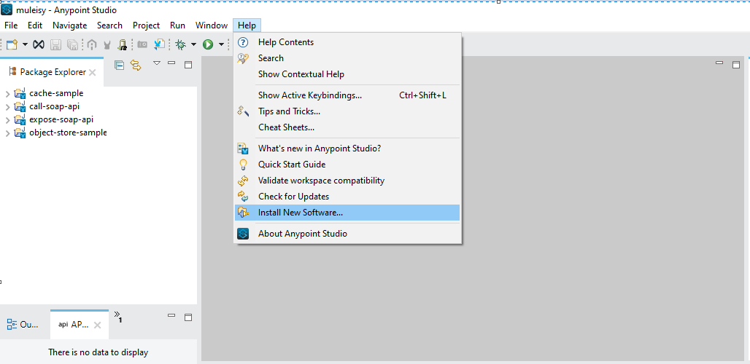

Add 🡪 <http://security-update-site-1.4.s3.amazonaws.com/> in Location

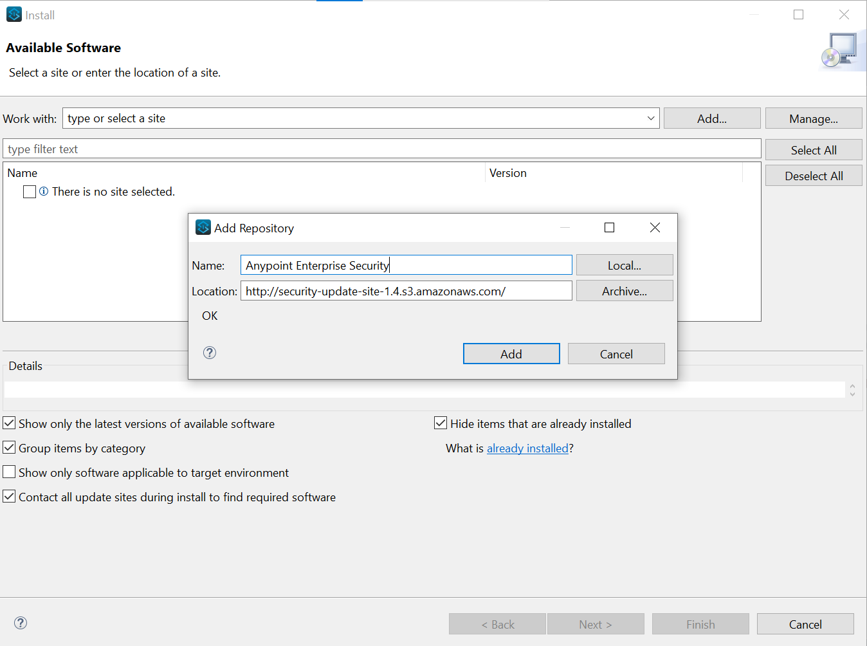

Select Premium and Click Finish

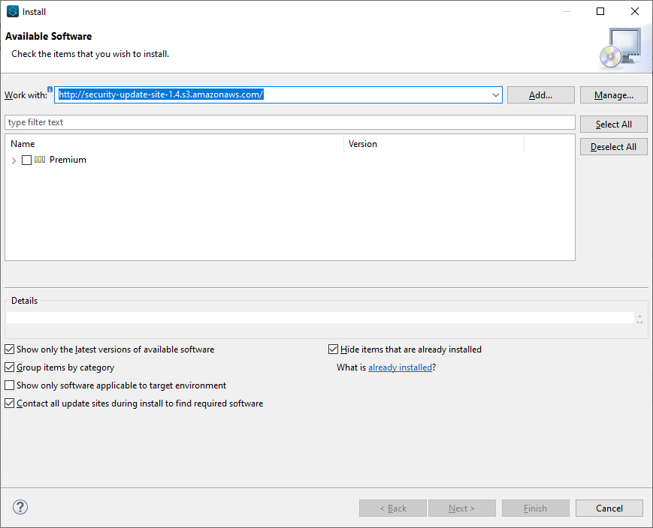

Click Next and Select Accept and Click Finish

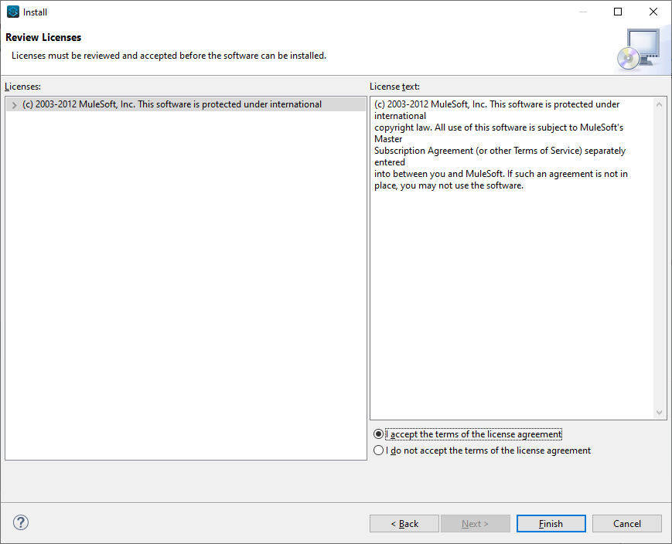

Select Install Anyway and Restart Now

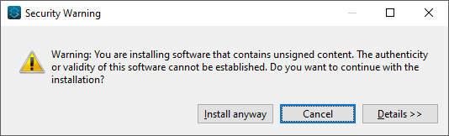

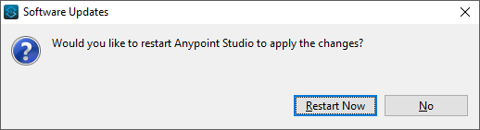

**STEP 2:**

Create New Mule Project

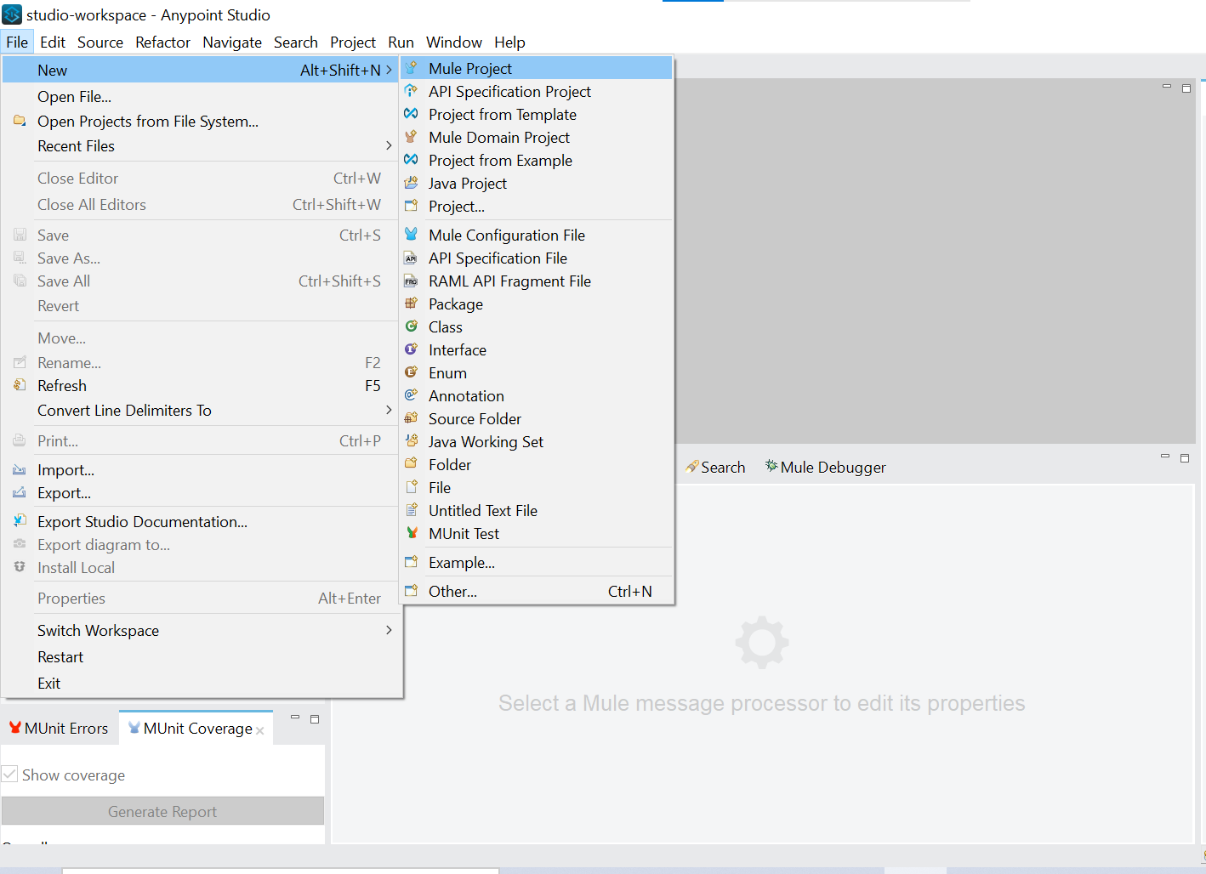

Name it as Secure-Properties-Project and Click Finish

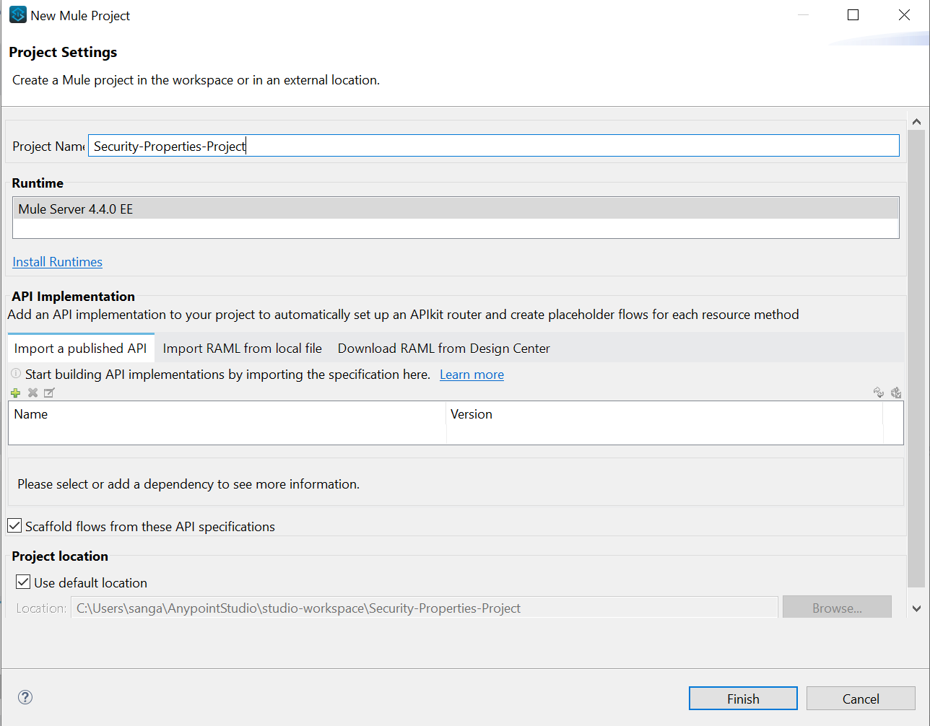

Create .yaml file in config folder in src/main/resource

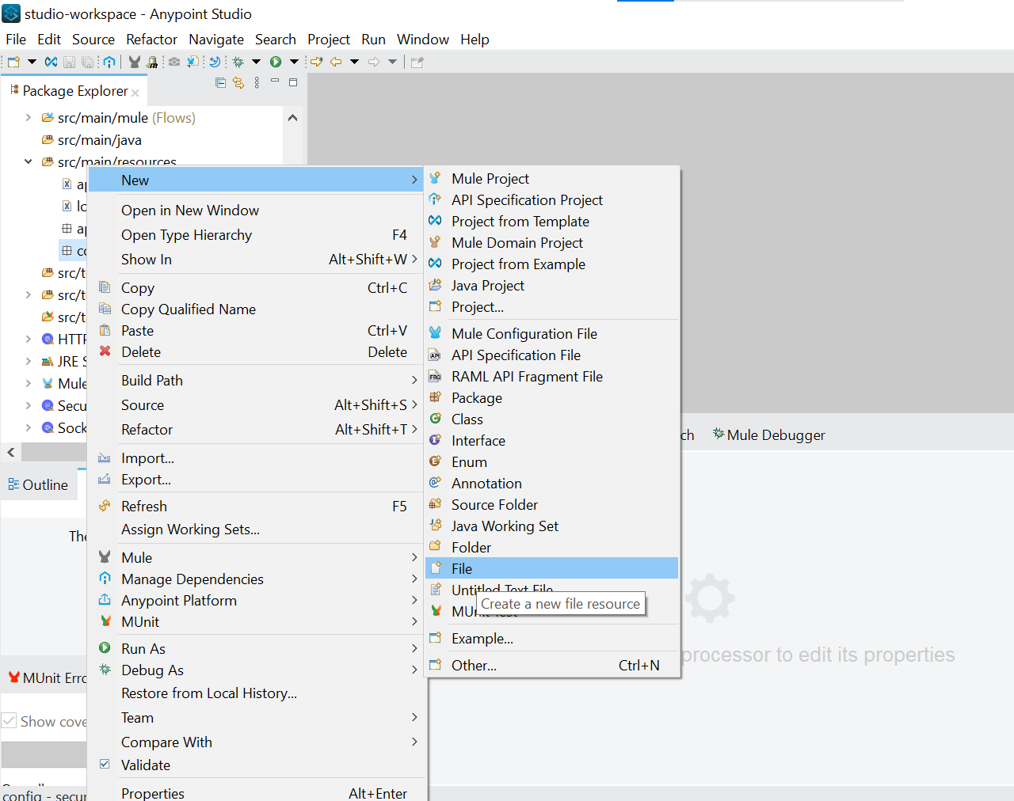

Give Name as config-dev.yaml and click finish

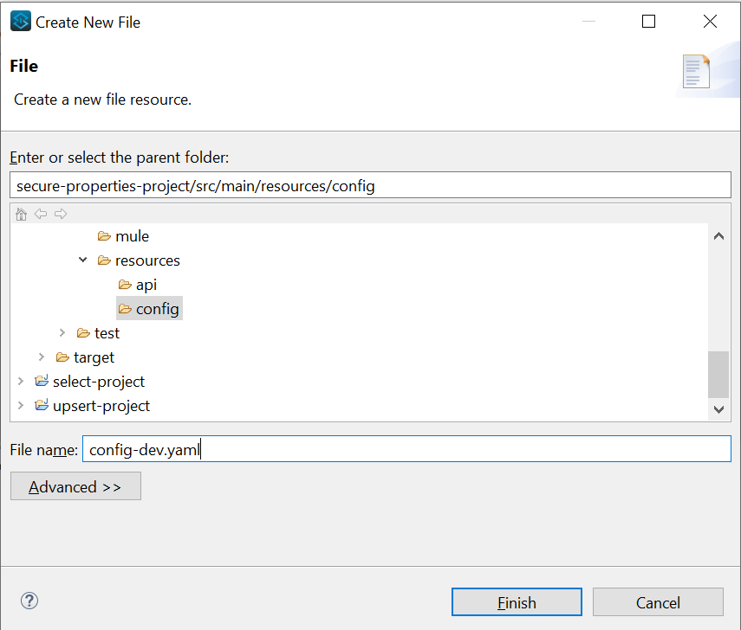

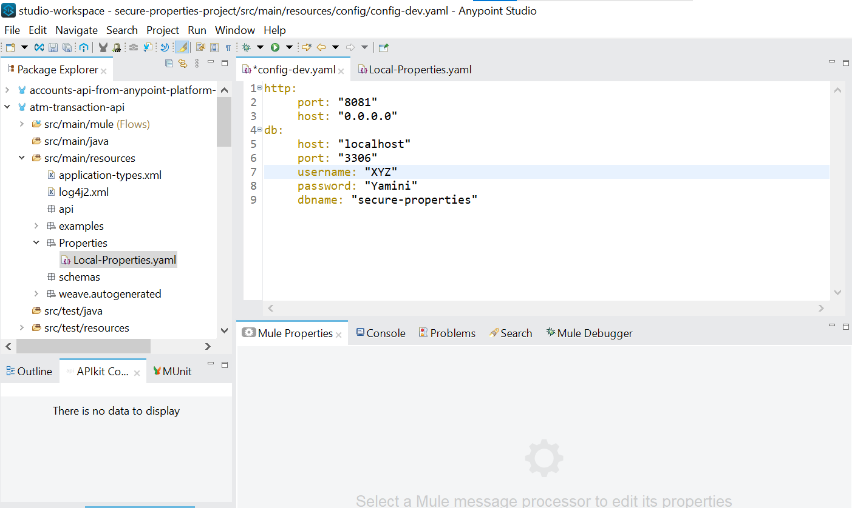

**STEP 3:** Connect all the required connectors

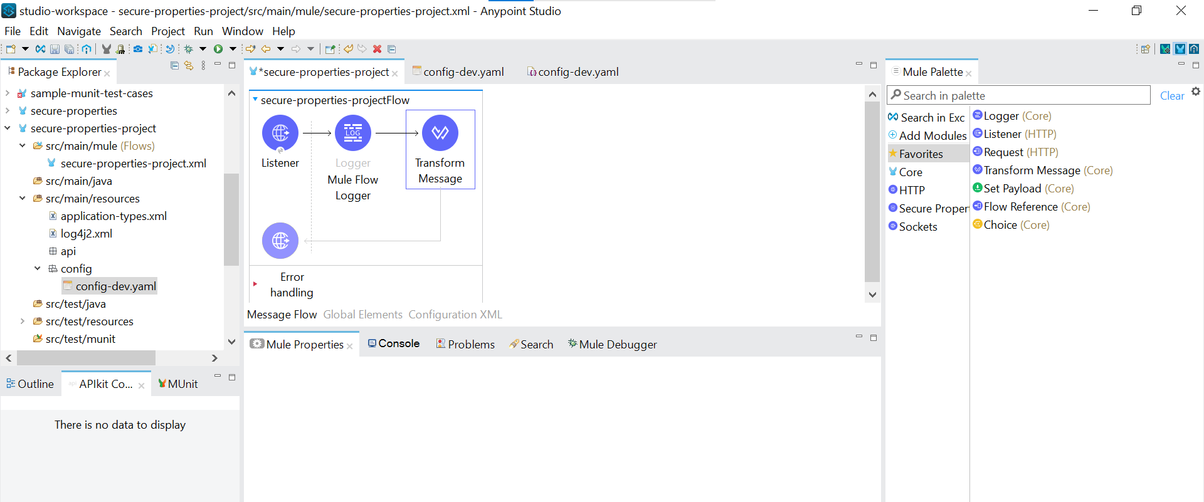

Configure the Http Listener Component by all the required properties

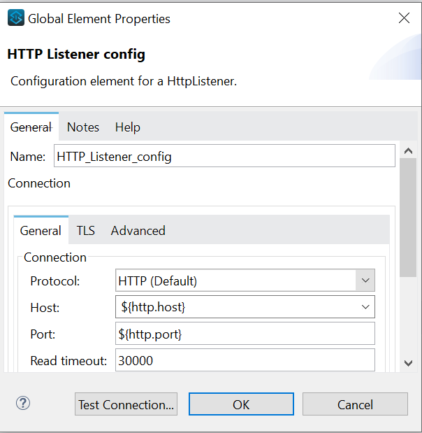

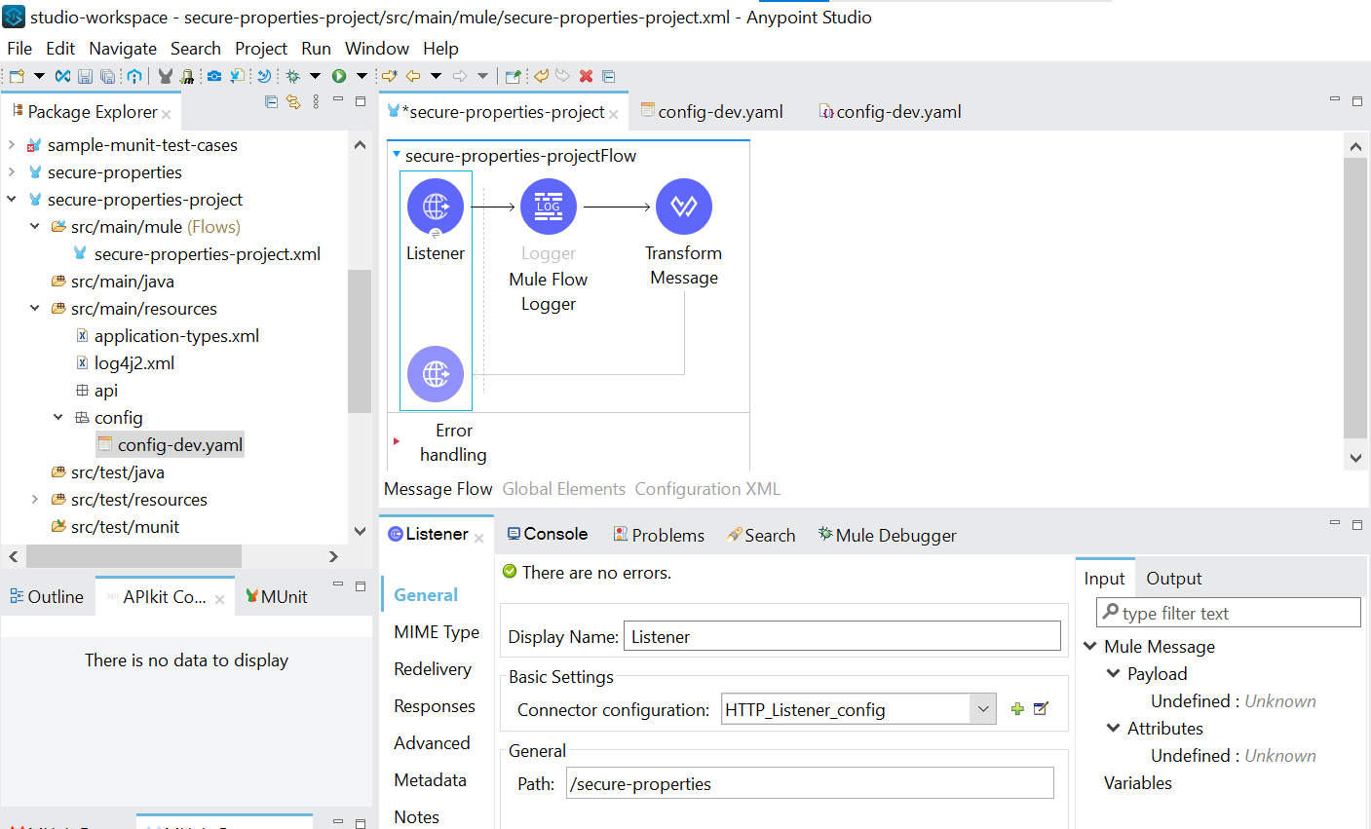

Provide a message in Logger --- Mule Flow DB username - ${secure::db.username} and password ${secure::db.password}

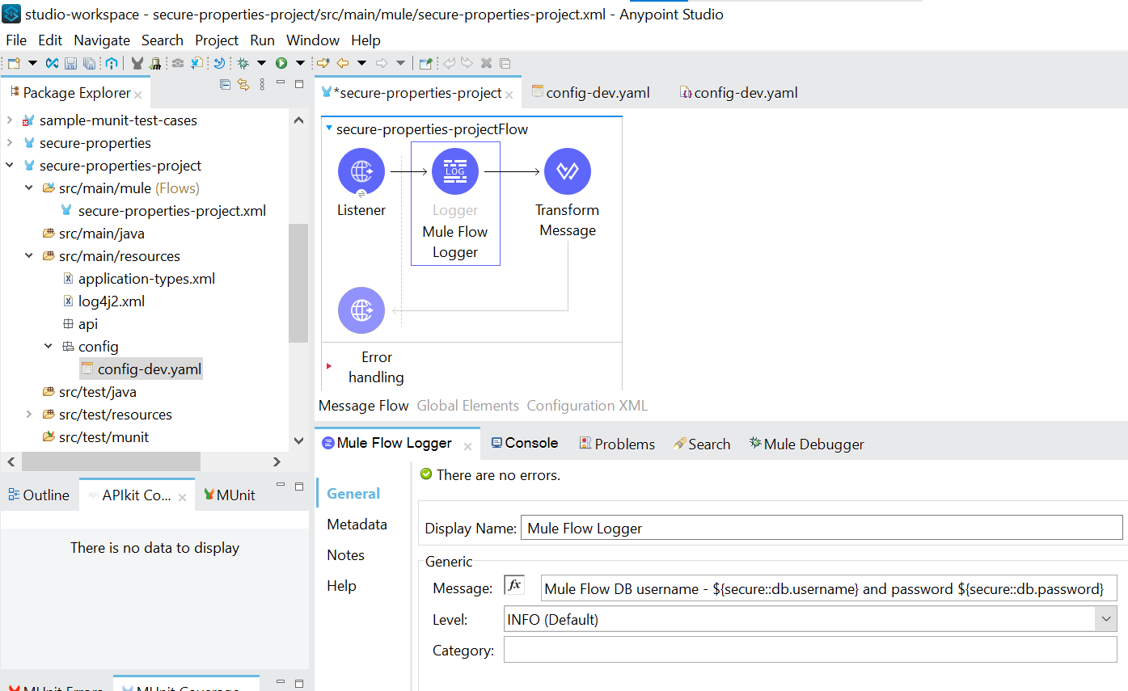

Write Data weave expression in transform message

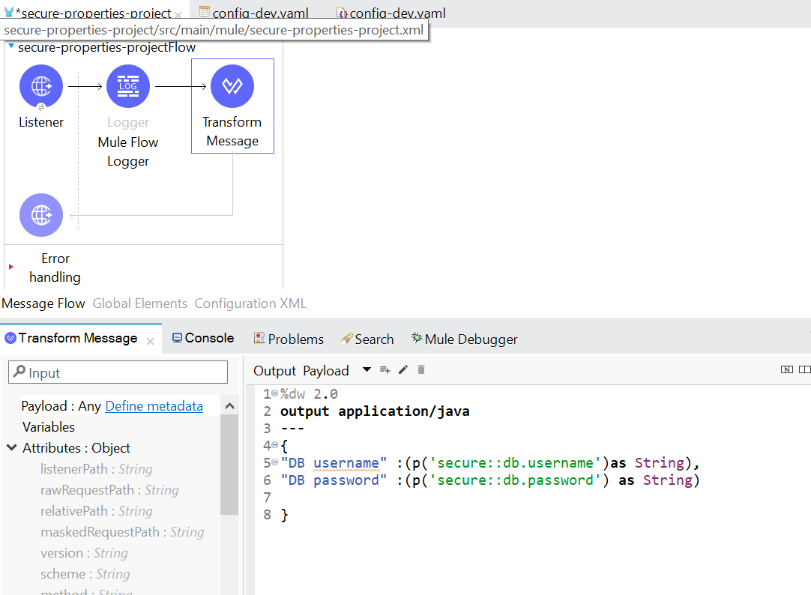

**STEP 4:**

Add Dependencies from Exchange

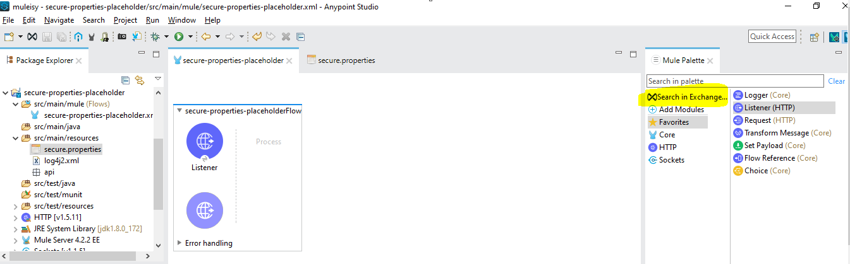

Type secure

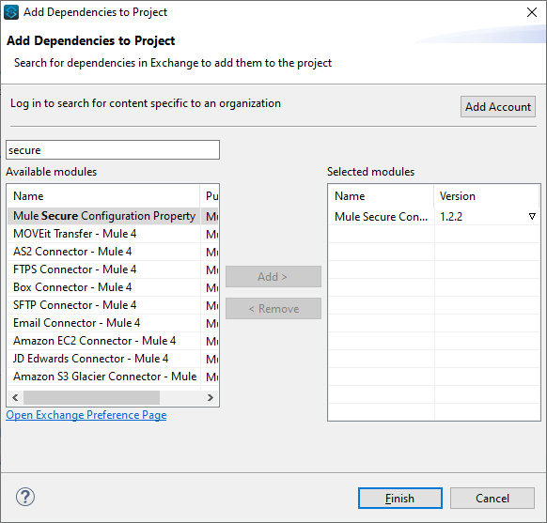

Add the Mule Secure Configuration Property module and Click Finish

Go back to Global properties and search for secure properties config

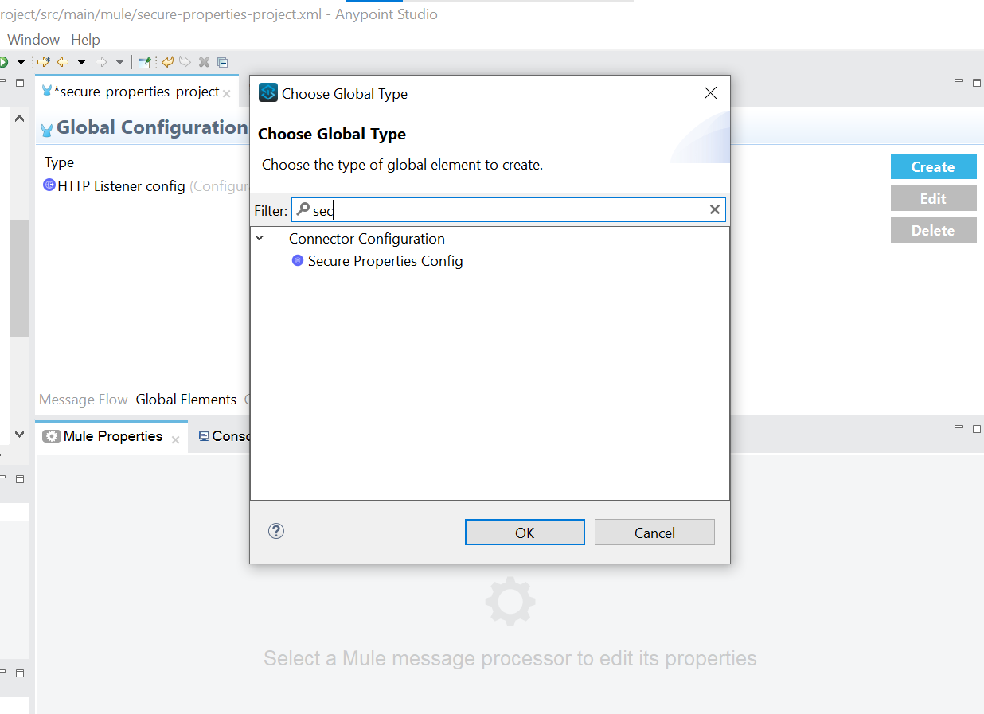

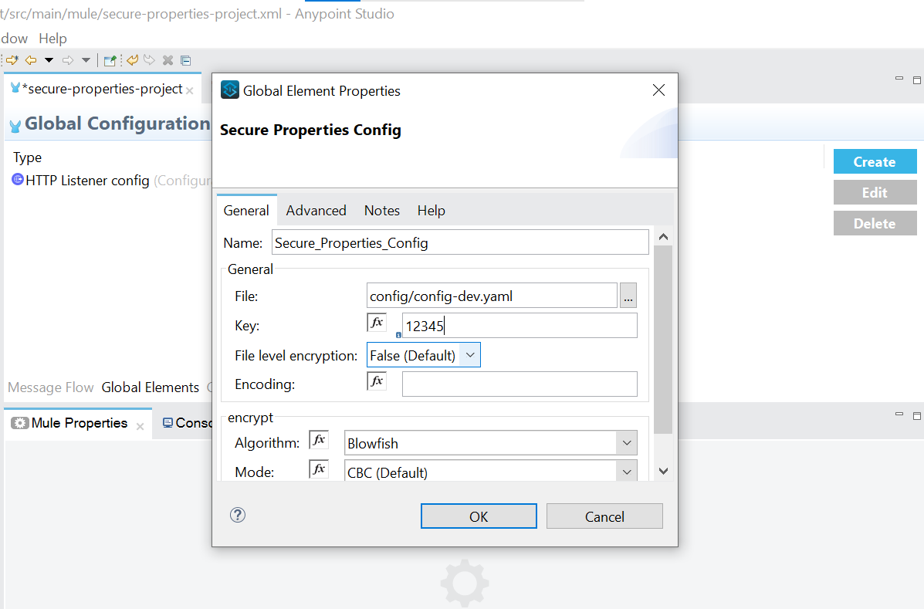

Provide Filename and key in Global Element Properties and Click ok

Run the project

